Participant instructions
Study: Assessing student emotion while programming

Overview
The following instructions will guide you through the setup process for taking part in the current study. It is important that you complete each step. If you experience any technical difficulties, please notify the experimenter. A troubleshooting section is also located at the end of this document.

1. Complete online survey
Step 1: Complete the survey and save the PIN

Please complete the following survey and, while doing so, save the randomized pin.
https://www.sqrlab.ca/survey/index.php?r=survey/index&sid=967883&lang=en

IMPORTANT: Please save the pin that is provided at the end of the survey by writing it down or taking a photo of it.

2. Download study files
- Open a terminal.
- Navigate to a working directory for this study
- In a web browser, visit [https:://GOOGLE DRIVE LINK]
- Download file “study_software.zip”
- Extract the file into the current directory
- You should have the following files in your working directory:
  - recording_script.py
  - requirements.txt
  - ij-plugin-0.1.0.zip

3. Check PyCharm Version
Make sure you are using the latest stable release of PyCharm (version 2025.2.2 as of September 28, 2025)
To check this:
- Click on the to open the Main Menu
  - On Mac, this will be in the top menu bar in PyCharm -> About PyCharm.
- Go to on Help -> About to get the below pop-up:
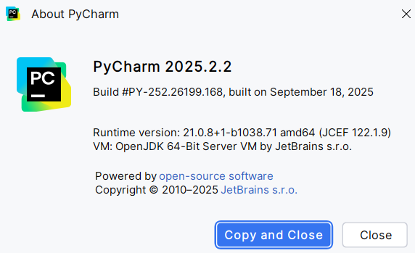
If it is not up-to-date, update your PyCharm installation by doing the following:
- Click on the to open the Main Menu
- Go to Help -> Check for Updates…
  - On Mac, this will be on the top menu bar
If you receive the following pop-up on the bottom of your screen, your PyCharm is already up-to-date:
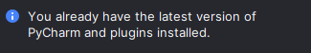

4. Install PyCharm-KOALA plugin
- Open PyCharm
- Open working directory in PyCharm
- Install the KOALA plugin.
- In PyCharm, click on the icon and select Plugins… to open the Plugins menu
- Click on the icon in the Plugins menu and select Install Plugin from Disk…
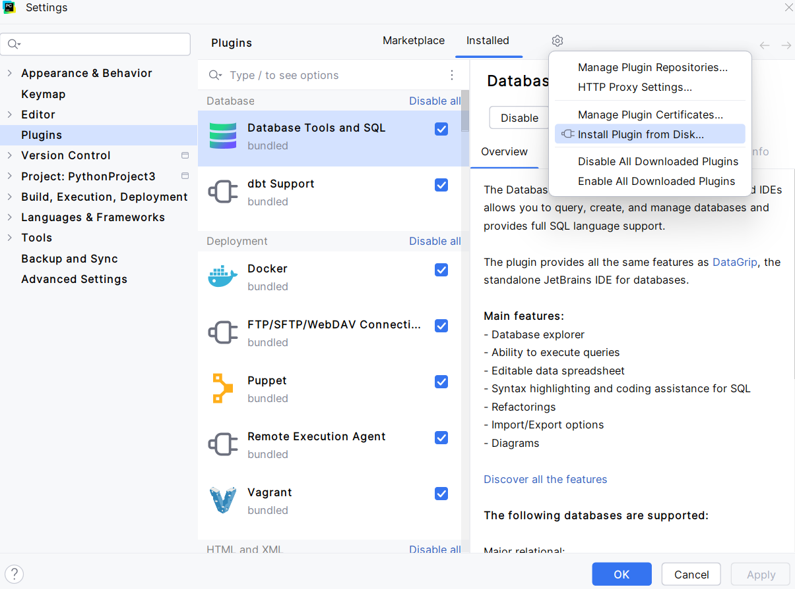

- Locate the ij-plugin-0.1.0.zip in the file explorer and click OK
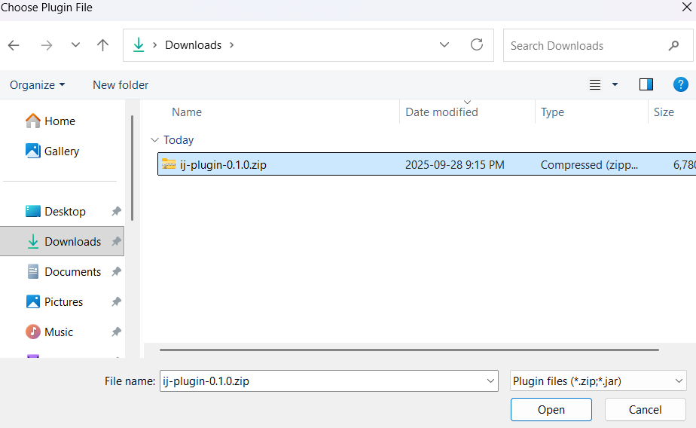
- Click Open in the plugins window to begin the installation. This will install KOALA on your IDE
- After a few moments, you should receive a prompt to restart PyCharm to complete the installation. Click Restart IDE and then Restart to proceed.
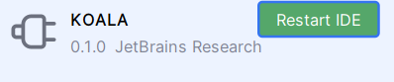
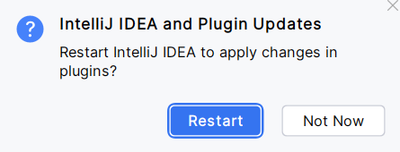
- PyCharm should reload with KOALA installed after this process.

5. Install Python (3.13.1)
- Check current version of python with “python --version”
- If version is below 3.13.1
  - Visit: https://www.python.org/downloads/release/python-3131/
  - Download and run the installer for your operating system.
Windows only: check “Add Python to PATH” before clicking Install.

6. Setup Python environment (venv)
- Open terminal.
- Navigate to a working directory for this study
- Run the following command to create a virtual environment
Windows: “python -m venv venv”
macOS/Linux: “python3 -m venv venv”
- Activate the venv:
Windows: “venv\Scripts\activate”
macOS/Linux: “source venv/bin/activate”
Note: You should now see (venv) appearing at the start of your terminal command line.
- Install Python package requirements with command:
Windows: “pip install -r requirements.txt”
macOS/Linux: “pip3 install -r requirements.txt”

This will install opencv, pandas, and av (for video processing).

For ‘uv’ users only, instead run:
Windows
- uv venv .venv
- .\.venv\Scripts\activate.bat
- uv pip install -r requirements.txt
macOS/Linux
- uv venv .venv
- source .venv/bin/activate
- uv pip install -r requirements.txt

7. Calibrate webcam
Launch a webcam app and position your camera as follows:
- Open any application that shows your webcam preview (for example, Google Meet, Zoom, or the system “Camera” app).
- Adjust the laptop/webcam so that your entire face is visible, including your forehead and chin.
- Aim for a straight-on view of your face: raise or lower the laptop or camera so it is approaching eye level, avoiding strong “looking up” or “looking down” angles.

8. Install webcam script
- In your working directory, launch screen recording program with
Windows: “python recording_script.py”
macOS/Linux: “python recording_script.py”
Script will display “Enter PIN to start recording:”
- Enter the pin provided from the online survey (no whitespace). Hit enter
Wait until the script displays “Recording started.”.
If not, please notify the experimenter.

9. Launch coding experiment

- In PyCharm, on the right side, can be found the icon:
- Click this icon and enter the PIN in the pop-up.
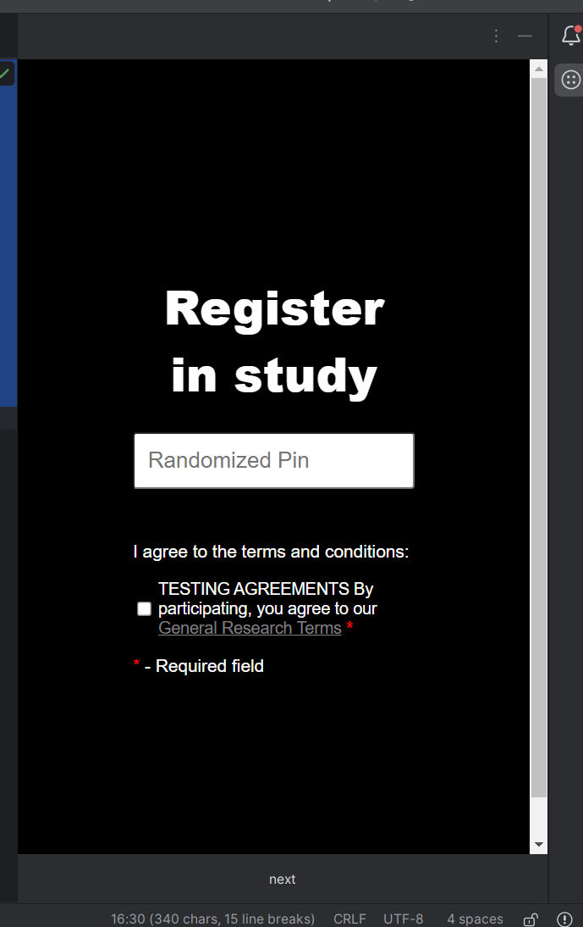
- Then click next to proceed to the next screen.
- IMPORTANT: Please complete the first task before proceeding to the next or if 10 minutes have passed. Each task should be completed in the preloaded python file and tested to ensure each test case has passed.
IMPORTANT: Please compile code with the run button in the top right corner of the PyCharm IDE rather than through the command line and do not use AI to solve the questions.
- Once a task is completed or 10 minutes has passed, please move on to the next task,
NOTE: When you are done with the task, please make sure to back up your file in a separate location before submitting it. The files can be found in the KOALA directory which is found in the root of the project.
- Once all the tasks have been completed please stop your recording script with control and c into the Terminal:
“Crtl+C”
- Upload all of the recordings into the following google form
https://forms.gle/AkWJGCvfs4w1TmN97
IMPORTANT: One submission per student. Ensure all files are added before submitting.

Uninstalling KOALA
Once the tasks have been completed, you can uninstall KOALA.
- Click on the icon at the top of PyCharm and select Plugins…
You will see three plugins to uninstall: Activity Tracker, JavaFX Runtime for Plugins, and task-tracker-plugin.
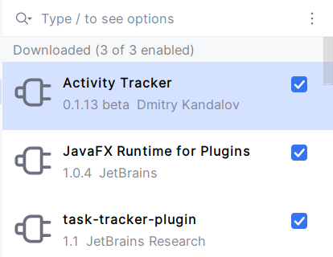
- On each of the plugins, click the and select Uninstall
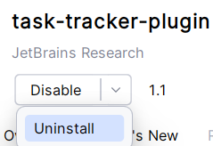
- Repeat this process for all three plugins
After all the plugins have been uninstalled, PyCharm will prompt you to restart.
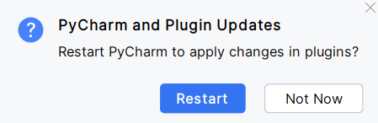
Click Restart to restart PyCharm. When it reloads, TaskTracker will be removed from PyCharm.

